DATABASES: A collection of data stored in a format that can be easily be accessed

collection of data? can be stored in any format

dsto mai best friend ka name uska collection kra hua hai in memory

shopping list paper

contact no. mobile

facebook jo ke data hai user ka computer

this all thing is called database management system...

now its not actual a database, but in order to create or manage we need a software applicaion

that is dbms.

advatnage:

make is easy to handled large amount of data daughter cant remember everything

import export of data

we can create multiple data

first we connect with it

and get actual data

and it responses

where and how we accessed?

sql(standard query language)

structured

sql is for table based database

vertical scalable

oracle

nosql:

document based

horizontol based

mongodb

what is sql?

standard language we use to talk to our databse

ex: find all users who are 16years old

select *FROM Users WHERE Age >= 16;

relational databse:

.mysql

.sqlite

.postrgressql

.oracle

.many other

all user sql(common) u can user any one permanently

mysql select *FROM Users WHERE Age >=16;

postgresql *FROM Users WHERE Age >=16;

we use cmd for mysql better than workbench

first open xampp and turn on apache and mysql from there

apache means php local server

how to run sql in cmd?

ans:

**goto c drive: cd..//..**

**C:\>**

**C:\>cd xampp/mysql/bin**

**C:\xampp\mysql\bin> //everyThing done in this folder**

now we have to connect

-u=userName, -p=password, h=localhost

and in phpMyAdmin folder theres config.inc which means local host ip, user and our password is there to start

**C:\>xampp/mysql/bin>mysql -u root -p -h localhost**

Enter password:"press enter because password is blank"

MariaDB [(none)]> //now we are in mariadb and we can use our mysql

we are connected with our local server

we are inside relational database

now we have to see that theres database present in it or not?

open localhost/phpmyadmin/ //apache should be open

in MySQL

datatypes

crud

refining data

logical oper

aggregate fun

pri/ for key

joins

constant

show database = show means how we see our databse.

and how much databases are present there

MariaDB [(none)]>show databases;

Database |

+--------------------+

| information_schema |

| mysql |

| performance_schema |

| phpmyadmin |

| test |

+--------------------+

5 rows in set (0.003 sec)

here are our databases. we can see our database by phpmyadmin and cmd also

how to create databases?

create anything like project, schoolproject,

clients, etc.

we can create as many databases as per our needed or not

create database <name>= "create our database"

**MariaDB [(none)]> create database hotelManagement;**

Query OK, 1 row affected (0.004 sec) //our database is created

we can create it from phpmyadmin also

check it by writing show database; command

**delete database using cmd and php?**

**drop database <name;> //will deleted database**

delete from php?

**goto database>operations>click Remove database>ok to drop>deleted**

if you want to use your database which you have created before

then "use" command will help to use it

and "select()" command will show your running database

**use database <name;>**

**select database(); //parenthesis is important**

relational databse always stored in table format.

now;

how many datatypes are there in it?

there are many datatypes in it

which is broken into 3 catergories

numeric strings date&time

TABLE:

FIELD = COLUMN

RECORDS = ROWS

PICTURE OF DATATYPES OF MYSQL: 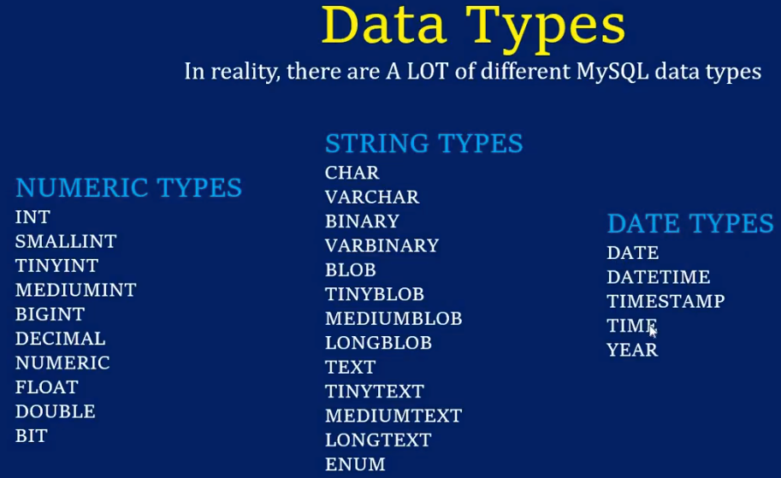

INT, VARCHAR AND DATE WITH MEANINGS:

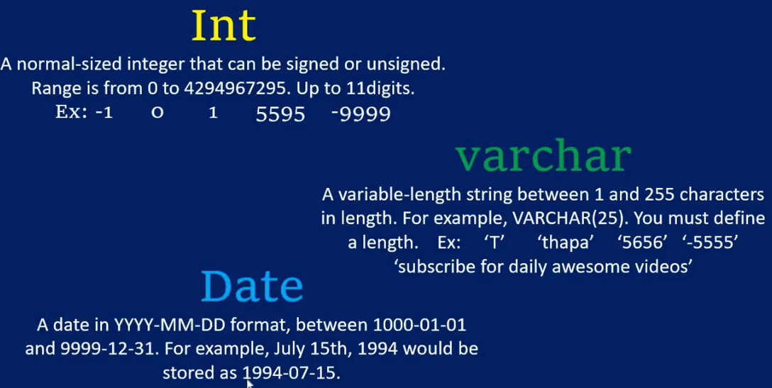

How we can create TABLES?

Commands for creating tables:

CREATE TABLE <tablename;>

(

column_name data_type,

column_name data_type,

column_name data_type

);

, 🡨 is used to separate many

Data type means int, string or datandtime

Columnname means which name u have to provide?

Show tables; we can see created tables by show

Desc customer; //table name is customer to see full description

Insert into customers

(id, name, class)

values(13933, ‘ahsan’, 10); //now enter after writing this.

Now how u can see your all data of your table

Select * from customers; // * means all data // from means where // customers table name..

Now how u know there is warning in it?

If you enter wrong data in table tthen it stored but give us warning

Show warnings;

Null vs not null in mysql using cmd and php….

Null

Means the value is not known

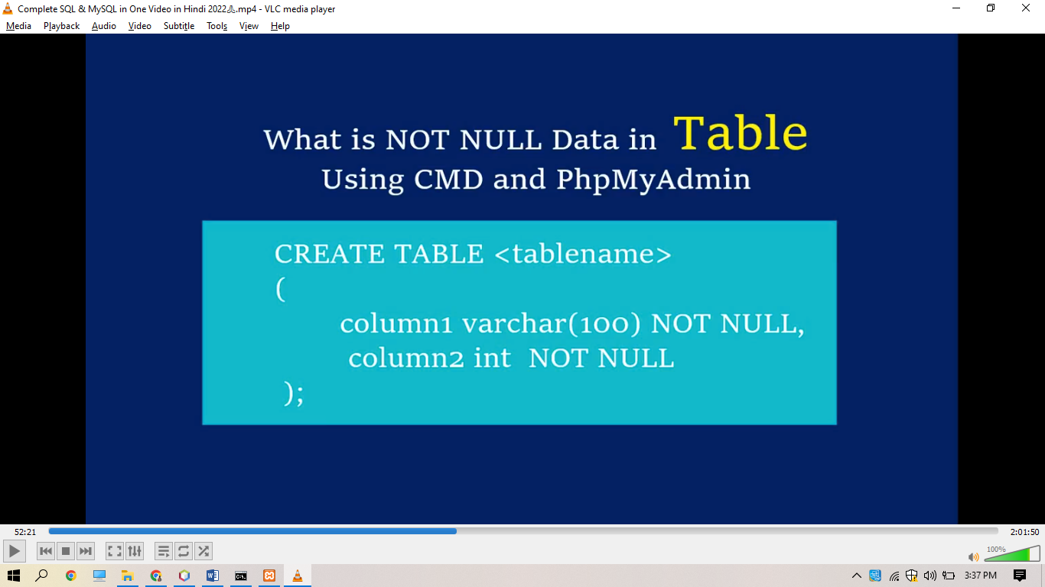 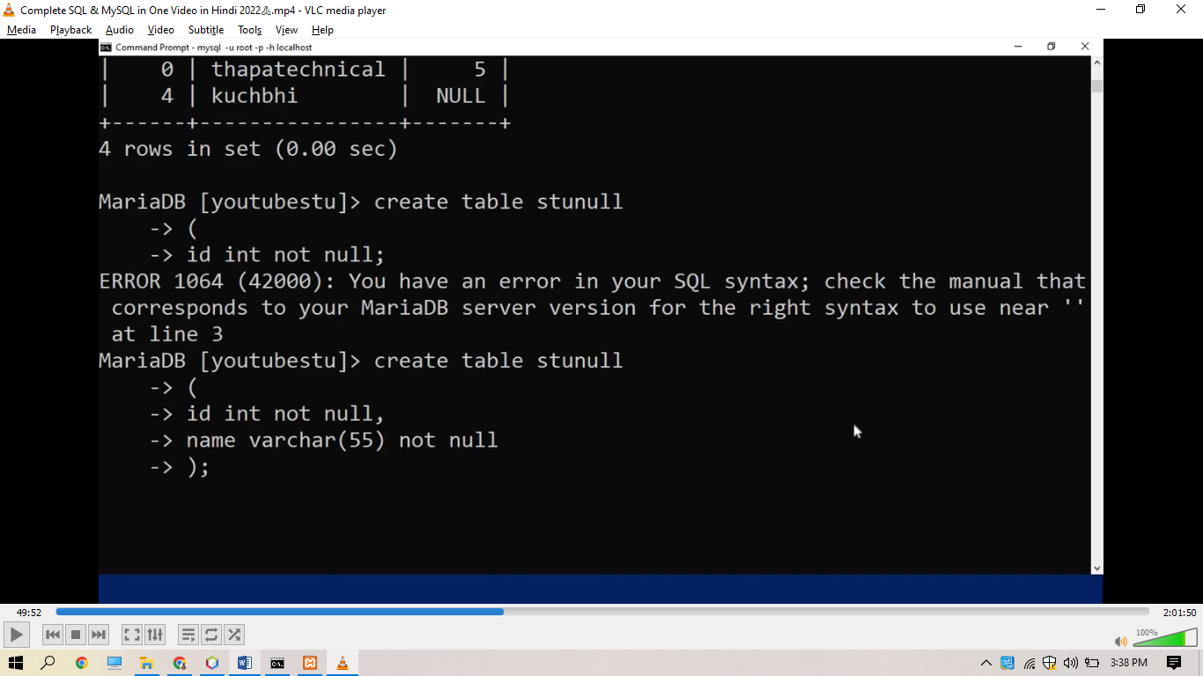 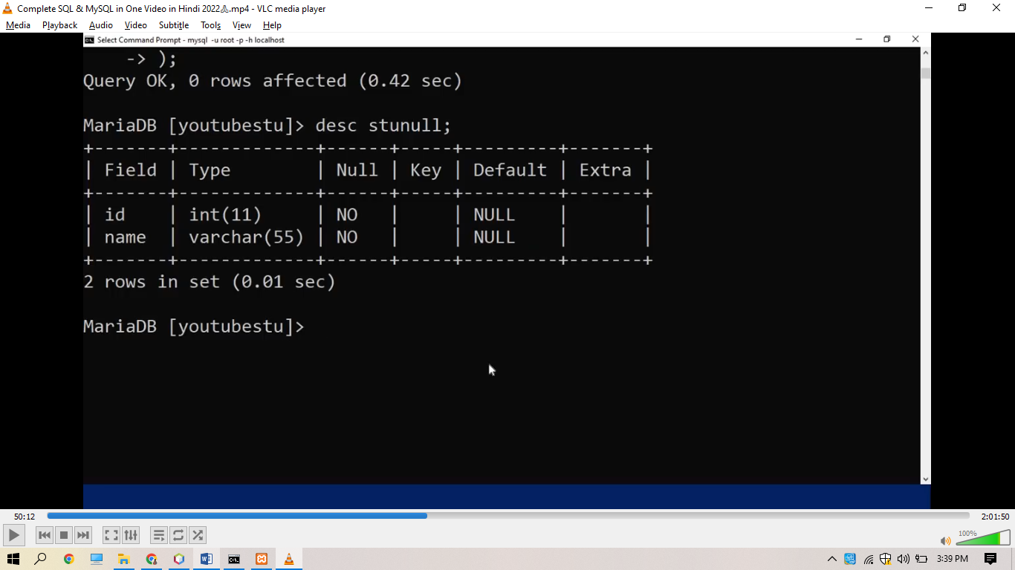now here no no in null means is that our table will not display us wrriten null in it. Is just display 0 if theres not any given data. 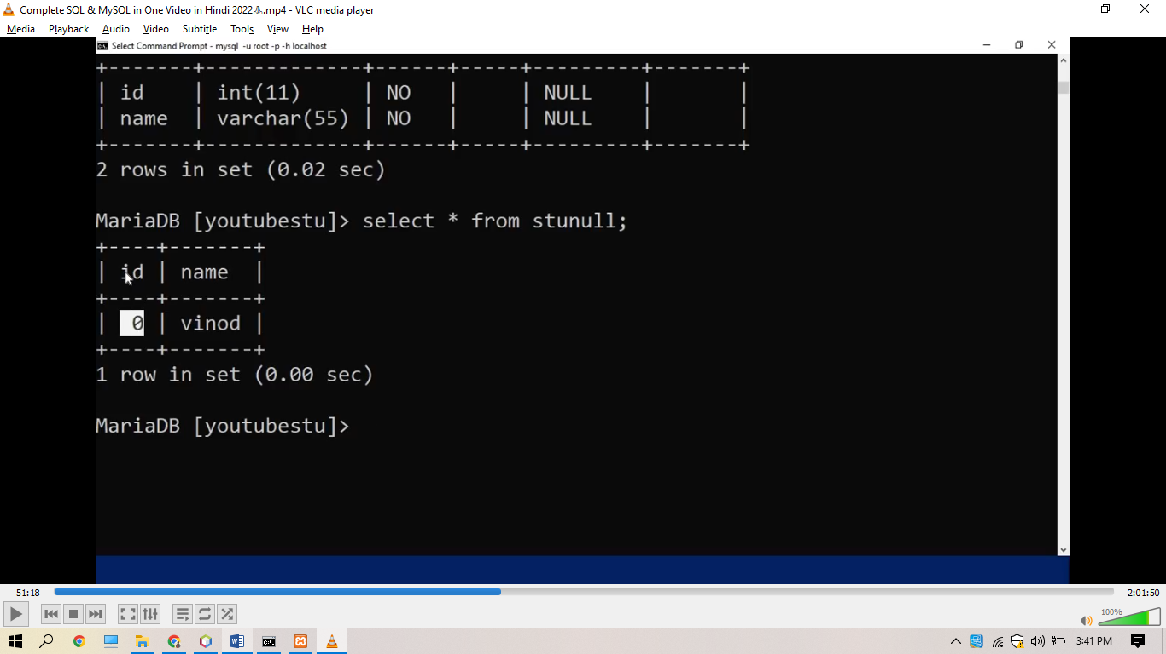

We can show our default null value also in our table

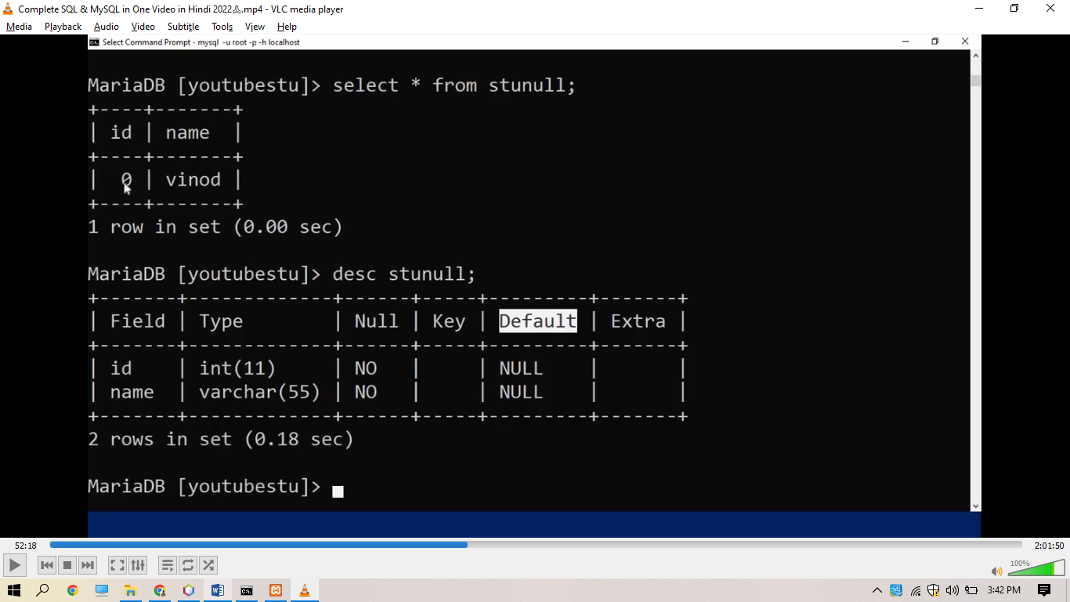in default there is null written. So we can provide our default value

We will create our default value table and see our values

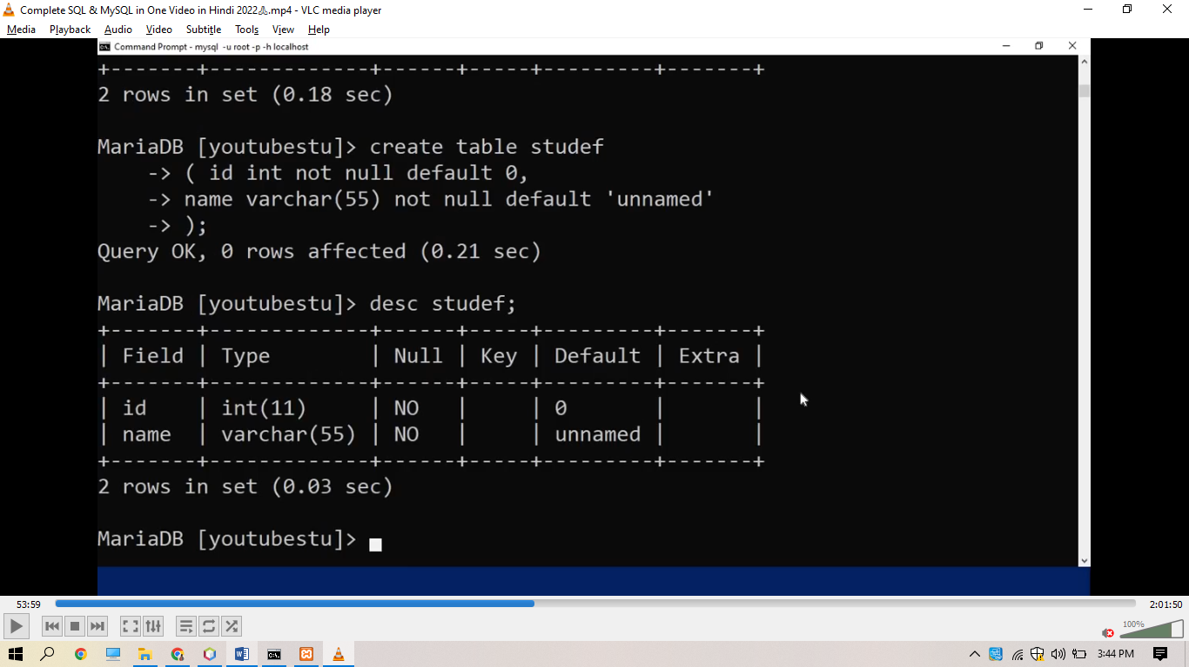

Here is our default value 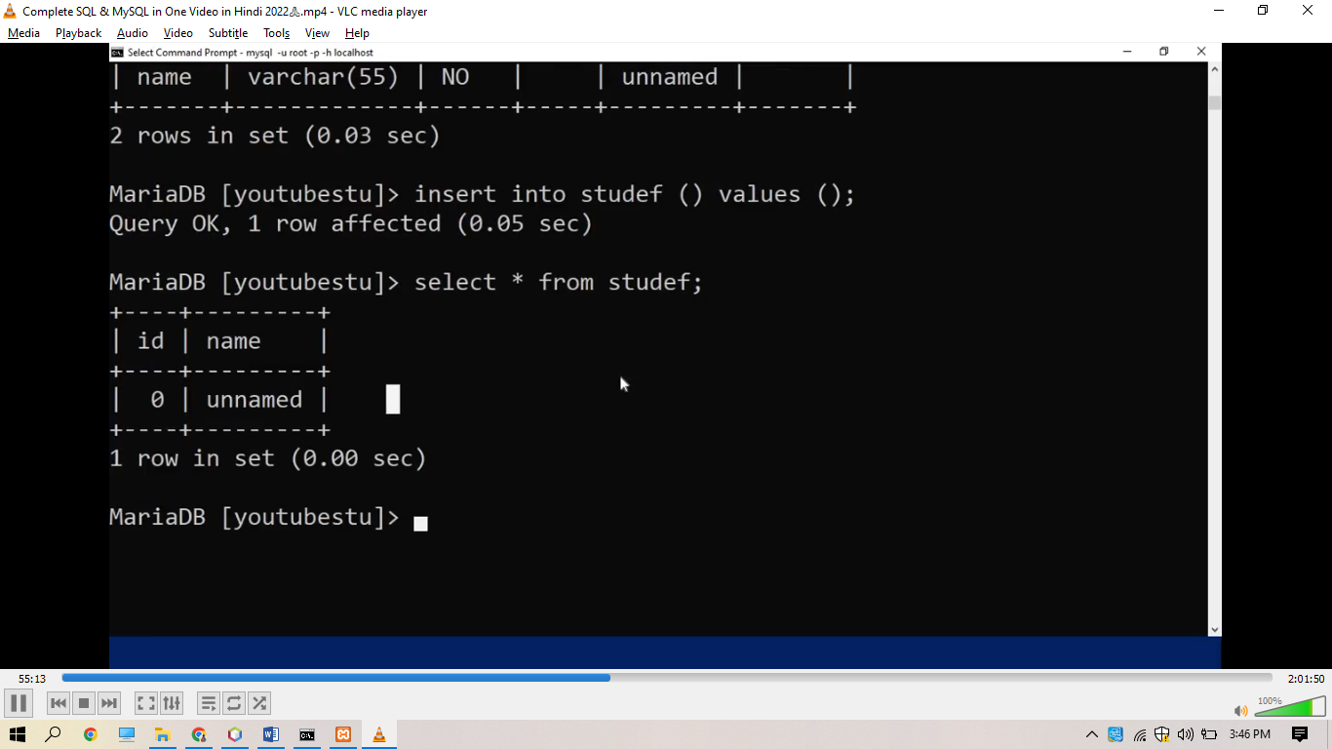

Now if you forgot to enter one more column then

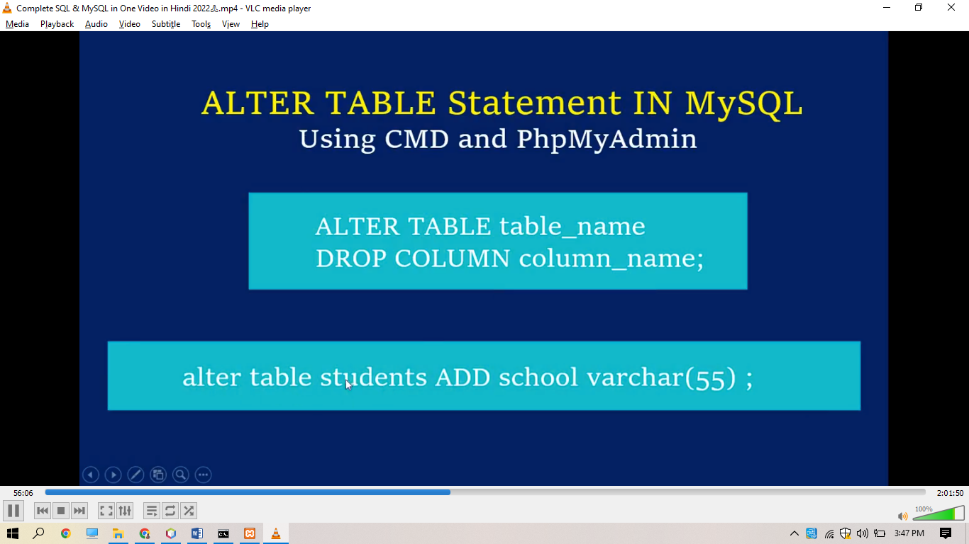

By writing alter

Alter table democustomers // means which table u have to add extra column

And alter table democustomers add school varchar(55);

MariaDB [hotelManagementSystem]> desc democustomers;;

+--------+-------------+------+-----+---------+-------+

| Field | Type | Null | Key | Default | Extra |

+--------+-------------+------+-----+---------+-------+

| name | int(11) | YES | | NULL | |

| class | int(11) | YES | | NULL | |

| Id | int(11) | YES | | NULL | |

| school | varchar(55) | YES | | NULL | |

+--------+-------------+------+-----+---------+-------+

4 rows in set (0.074 sec)

Now if u want to delete any extra column then ……….

MariaDB [hotelManagementSystem]> alter table democustomers drop column id;

Query OK, 0 rows affected (0.075 sec)

Records: 0 Duplicates: 0 Warnings: 0

MariaDB [hotelManagementSystem]> desc democustomers;;

+--------+-------------+------+-----+---------+-------+

| Field | Type | Null | Key | Default | Extra |

+--------+-------------+------+-----+---------+-------+

| name | int(11) | YES | | NULL | |

| class | int(11) | YES | | NULL | |

| school | varchar(55) | YES | | NULL | |

+--------+-------------+------+-----+---------+-------+

3 rows in set (0.067 sec)

Our id column is deleted by alter drop

PRIMARY KEY

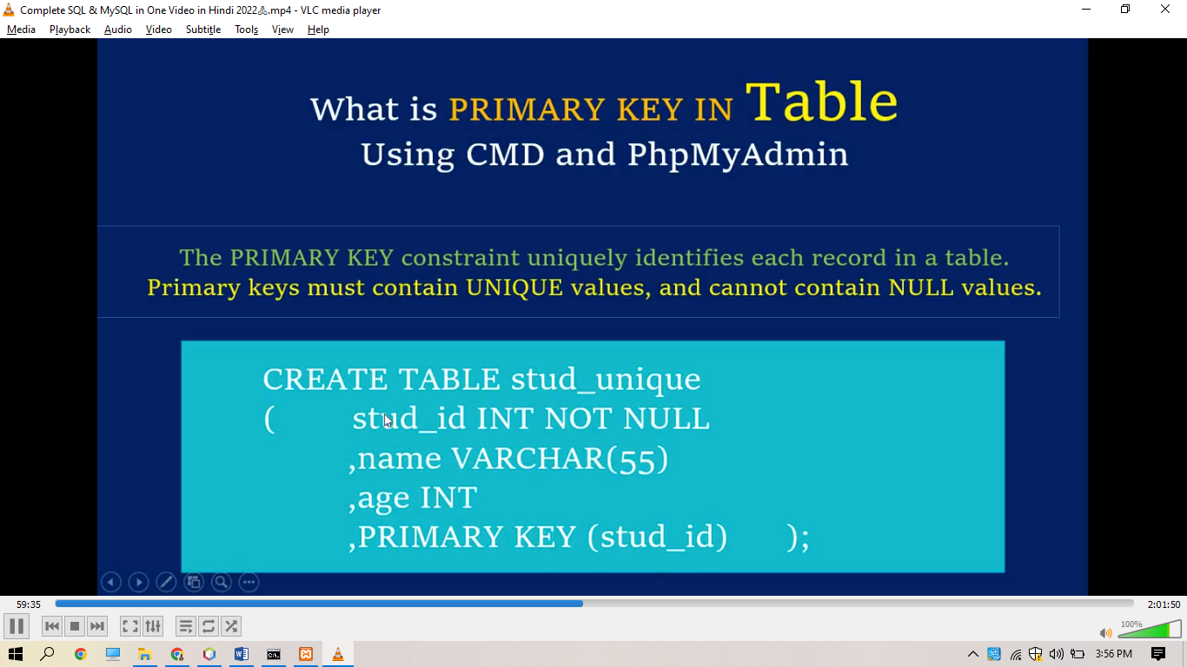

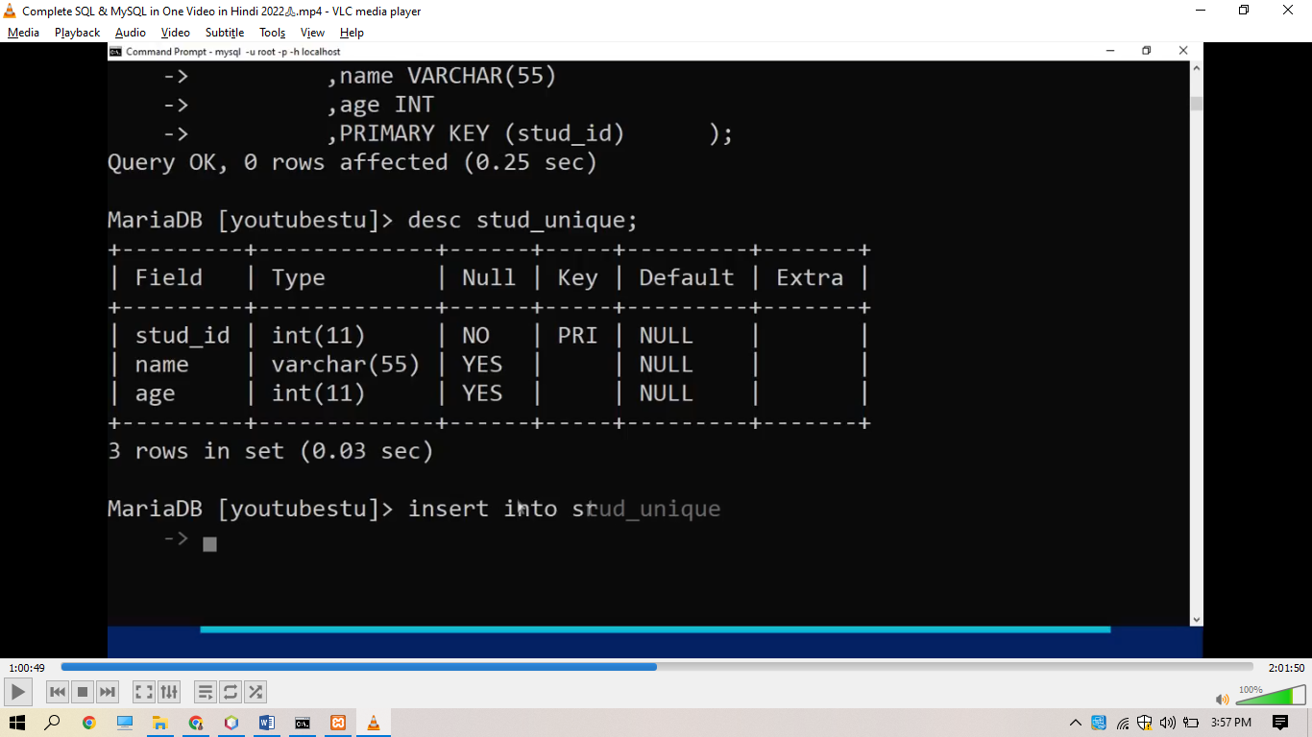

Here primary key means specific key which is any key like 1 2 3 4 5

So in previous ss we have done it already and give primary key to stu_id;

Here key is incrementing by manually

But we have to increment it automatically

So for this we will write AUTO_INCREMENT

Which allow unique numbers to generate automatically

